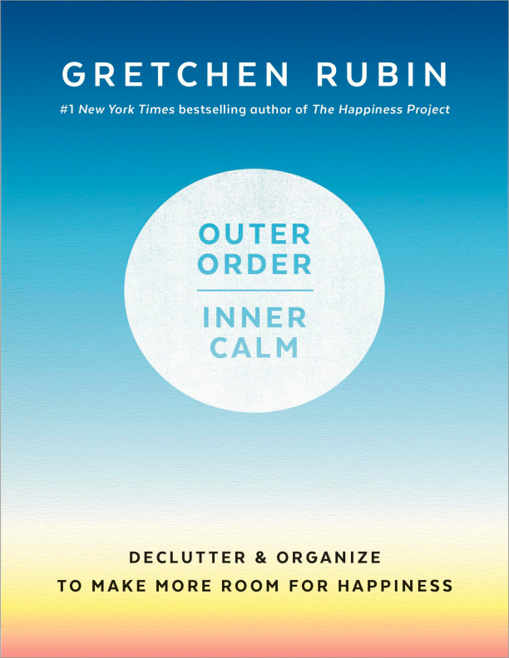
ALSO BY GRETCHEN RUBIN
The Four Tendencies
Better Than Before
Happier at Home
The Happiness Project
Forty Ways to Look at JFK
Forty Ways to Look at Winston Churchill Power Money Fame Sex: A User’s Guide Profane Waste (with Dana Hoey)
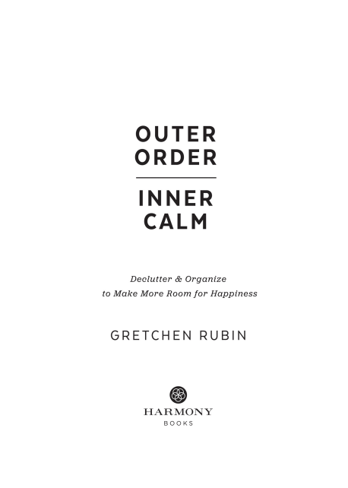
Copyright © 2019 by Gretchen Rubin
All rights reserved.
Published in the United States by Harmony Books, an imprint of the Crown Publishing Group, a division of Penguin Random House LLC, New York.
crownpublishing.com
Harmony Books is a registered trademark, and the Circle colophon is a trademark of Penguin Random House LLC.
Library of Congress Cataloging-in-Publication Data
Names: Rubin, Gretchen, author.
Title: Outer order, inner calm : declutter and organize to make more room for happiness / Gretchen Rubin.
Description: New York : Harmony, 2019.
Identifiers: LCCN 2018029854 (print) | LCCN 2018035349 (ebook) | ISBN 9781984822819 (e-book) | ISBN 9781984822802 (hardback)
Subjects: LCSH: Self-actualization (Psychology) | Happiness. | Success. | BISAC: SELF-HELP / Personal Growth / Happiness. | HOUSE & HOME / Cleaning & Caretaking. | SELF HELP / Personal Growth / Success.
Classification: LCC BF637.S4 (ebook) | LCC BF637.S4 R8283 2019 (print) | DDC 158-- dc23
LC record available at https://lccn.loc.gov/2018029854
ISBN 9781984822802
Ebook ISBN 9781984822819
Cover design by Danielle Deschenes
Illustrations by Jon McNaught
v5.3.2
prh
To my readers, listeners, and viewers
Order is Heaven’s first law. ALEXANDER POPE
CONTENTS
INTRODUCTION | Why Bother with Outer Order?
1 | Make Choices
2 | Create Order
3 | Know Yourself—and Others
4 | Cultivate Helpful Habits
5 | Add Beauty
CONCLUSION | The Fulfillment of Inner Calm
Acknowledgments
Top Ten Tips for Creating Outer Order
Suggestions for Further Reading
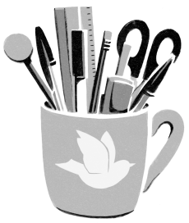
INTRODUCTION
Why Bother with Outer Order?
In my study of happiness, I’ve realized that for most of us, outer order contributes to inner calm.
More than it should.
In the context of a happy life, a messy desk or a crowded coat closet is a trivial problem—yet getting control of the stuff of life often makes it easier to feel more in control of our lives generally.
When I’m surrounded by a mess, I feel restless and unsettled. When I clean up that mess, I’m always surprised by the disproportionate energy and cheer I gain, plus I’m able to find my keys. A friend once told me, “I finally cleaned out my fridge and now I know I can switch careers.” I knew exactly what she meant.
By getting rid of the things I don’t use, don’t need, or don’t love, as well as the things that don’t work, don’t fit, or don’t suit, I free my mind—and my shelves—for what I truly value. And that’s true for most people.
Often, when disorder starts to creep in, I think, I don’t have time to fight my way through all this stuff! I’m too busy to deal with it! But I’ve learned that by managing my possessions, I can improve my emotional attitude, my physical health, my intellectual vigor, and even my social life.
Now, no matter how busy I am, I force myself to take at least a few minutes each day to impose some order. If I’m feeling overwhelmed by multiple writing deadlines, I spend twenty minutes cleaning my office, because I know that clearing my papers clears my mind.
I’ve also found that once I start, it’s easier to keep going. True, sometimes it feels auspicious to do a big clutter-clearing on New Year’s Day, or as spring cleaning, or as pre–Labor Day prep—but now is always the best time to begin. A friend told me, “I woke up one morning and on impulse decided to tackle my basement. I spent my entire Sunday down there, and I was so pumped by the end that I wanted to keep going all night. I got up early on Monday morning just to sit there and gloat. It gave me such a lift at the start of a tough workweek.”
We want to cherish our possessions and we also want to feel free of them. I want to keep every toy that my children ever loved, but I also want to have plenty of space in our apartment.
With outer order, we achieve that balance.
Outer order offers nine promises:
1
OUTER ORDER SAVES TIME, MONEY, SPACE, ENERGY, AND PATIENCE. I move more smoothly through my days. I don’t waste time searching for things; I don’t struggle to put things away; I don’t have to run out to buy a duplicate of something I already own. It’s easier to clean. I feel less frustrated, less rushed, and less cramped. I’m not frittering my life away on trivial chores and annoyances.
2
OUTER ORDER FOSTERS PEACE WITHIN RELATIONSHIPS. I spend less time nagging at or arguing with other people. I avoid boring questions like “Where’s my passport?” “Where’s the toner?” “Who left the mess in that room?” “Where does this go?”
3
OUTER ORDER CREATES A FEELING OF SANCTUARY. I experience true leisure because I don’t feel pressured to jump up and deal with a mess. Once visual noise is eliminated, I feel more focused and there’s more room in my mind, my schedule, and my space for creative activity. Instead of being sources of stress, my home and my office are places of comfort and energy. I can revel in the beauty of my possessions because I can see and reach everything easily. I have plenty of room for everything that’s important to me. Our physical experience colors our emotional experience, and when my body is in a place that’s orderly, my mind becomes more serene.
4
OUTER ORDER REDUCES GUILT. I feel relieved of guilt about the possessions I’ve never used and the projects I’ve never finished. Because I make better use of what I already own, I can buy less in the future. And I know I’ll leave a lighter burden for others to handle after I’m gone.
5
OUTER ORDER ALLOWS ME TO PROJECT A MORE POSITIVE IDENTITY TO MYSELF AND TO THE WORLD. I feel greater self-possession; I feel more self-assured and capable. Once I’ve cleared away the things I don’t need, use, or love, my surroundings reveal to me, and to others, the things that matter most to me. Careful curation means that my space and my possessions reflect my truest identity.
6
OUTER ORDER RELIEVES ME OF THE FEAR OF PEOPLE’S JUDGMENT. I’m more hospitable because I can invite people over without hours of preparatory cleaning. I don’t panic at the prospect of an unexpected guest or an emergency repair. I’m pleased to show my space to others.
7
OUTER ORDER REFLECTS WHAT’S HAPPENING NOW IN MY LIFE. Because I’ve let go of things that once—but no longer—played an active role in my life, I have more time for what’s important right now. No more giant toys from my children’s babyhood, no more rows of thick law books crowding my office bookshelves. I keep a few precious mementos from the old days, but most of my space is devoted to what’s important now.
8
OUTER ORDER CREATES A SENSE OF POSSIBILITY. When too much stuff piles up, I feel paralyzed. Digging myself out of the mess seems insurmountable, so I stay stuck. When clutter is gone, I have more
choices about the future: what to buy, what to do, where and how to live. Because I’m no longer hemmed in by possessions, I feel a sense of renewal.
9
OUTER ORDER SHARPENS MY SENSE OF PURPOSEFULNESS. I know what I have, why I have it, and where it belongs. I make good use of everything I own. There’s nothing random, no uncertainty, no default choices. I’m surrounded by meaningful possessions that are ready for me to use them.
Our rooms shape our thoughts, and our possessions change our moods. It can be challenging to influence our thoughts and actions directly; by improving the state of our surroundings, we can improve our state of mind.
Because our minds feed on the experience of our five senses, pleasing our senses raises our spirits.
Given how much clutter affects my own happiness and the enthusiasm for this subject in popular culture, I’m surprised that researchers haven’t investigated the effects of clutter more thoroughly. The studies that do exist tend to address questions such as whether it’s “better” to be organized or messy. To me, the answer seems obvious: It depends. We all differ in what works “better.”
We all must face clutter in the way that’s right for us. We’re all different—in what possessions we value, in the kinds of surroundings that we find pleasurable, in the kinds of habits that come naturally to
us, in the dynamics of our household or workplace. There’s no one “right” or “best” way to create a better life.
In fact, we should work to create outer order only if it makes us happier. There’s no magic in making a bed, or filing papers, or emptying an in-box each night. These efforts are worthwhile only if they bring us more happiness. We’ve achieved the right level of order when we can find what we need, feel good in our space, and don’t feel hindered by stuff. For some people, what looks like disorder works just fine.
Why, then, do so many experts insist that they’ve found the one true and right way? It’s a fact about human nature: when getting advice, we love to receive a precise, standardized template for success, and when giving advice, we love to insist that the strategy that works so well for us will surely work for others. But each of us must find our own way.
Some people want to clear a little clutter each day; some people want to work for fourteen hours straight. Some people struggle with overbuying; some people (like me) struggle with underbuying. Some people feel a strong emotional or mystical attachment to possessions; others don’t feel much connection to objects. Some people curate their possessions with great care; others put little thought into what they buy and where they put it. Some people are powerfully attracted by the promise of minimalism—and some people aren’t.
Nevertheless, while each of us might define and achieve outer order in different ways, it’s clear that for most people, outer order does indeed contribute to inner calm.
Some people ask me, “Given the problems of the world, isn’t it superficial and silly to devote time, energy, money, or concern to tackling clutter?” We may be deeply worried about the problems of the world, and we’re right to be worried. Yet the promise of outer order is
something that we can tackle on our own right now. By doing so, we help restore our equanimity—and this isn’t a futile or selfish gesture, because that equanimity makes us more effective when we seek to address the problems of the world.
Outer Order, Inner Calm lays out the five stages for establishing outer order. First, we make choices—what possessions to keep and what to do with them. Once we’ve cleared through our things, we create order by organizing, repairing, and attending to neglected areas. Next, we reflect on ourselves, to know ourselves—and others—so that we can take those individual insights into account. Then, once the clutter is vanquished, it’s useful to cultivate helpful habits to maintain that order, so the clutter doesn’t return. The fifth and final step is to add beauty to make our surroundings more inviting and comfortable.
The chapters covering these five stages encompass a wide range of suggestions about how to create outer order. Different ideas appeal to different people, and each reader can adopt those ideas that strike a chord—and ignore the ones that don’t resonate. When we tailor our approach to suit our own particular challenges and habits, we’re far more likely to be able to fashion the order we desire. Outer Order, Inner Calm isn’t a book about how to clean a house or an office; it’s a book about how to boost happiness by creating the outer order that fosters inner calm.
Step by step—as part of our ordinary routine, without spending a lot of time, energy, or money—we can create the orderly surroundings that help us to live happier, healthier, more productive, and more creative lives.
Whenever you read this, and wherever you are, you’re in the right place to begin.
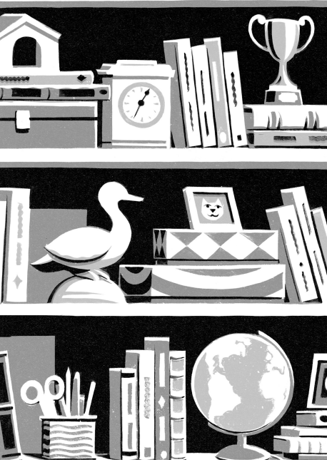
1
Make Choices
If you want a golden rule that will fit everybody, this is it: Have nothing in your houses that you do not know to be useful, or believe to be beautiful.
WILLIAM MORRIS
Clearing clutter is a big challenge. Why? One reason is that the process requires us to make taxing choices about what to keep, what to discard, and why.
Often, to make those choices, we must confront the reason that we’ve accumulated that clutter in the first place. Do any of these explanations sound familiar?
This thing is so useful that someday I’ll find a way to use it. I could get this thing fixed or altered.
Life’s too short to spend my time dealing with this thing. This thing was a gift, so I need to keep it out of respect for the giver. This thing hasn’t been used up yet.
Just wait, someday this thing will be a collector’s item!
I never had this thing as a child, so I want to have it as an adult. The more things I keep, the more I will leave my family one day. This thing reminds me of someone I love.
If I deal with this thing now—if I make my bed or wash this dish— I’ll just have to deal with it all over again tomorrow.
I’m more creative with all these things around me.
I can’t deal with this thing until everyone around me agrees about what we should do with it.
Someday, I might need this thing.
I don’t have the space to put away this thing properly. When I have time, I could do a cool project with this thing.
Going through my things stirs up my emotions and I can’t handle that right now.
Everyone I know has this thing, so I should have one, too.
I don’t have the time or the energy to decide what to do with this thing.
If I get rid of this thing, and other things, my home or office will feel sterile and stripped.
I’ve had this thing for so long; I can’t get rid of it now.
I forgot about that thing! I didn’t even realize it was there. This thing will feel lonely or abandoned if I get rid of it.
I’ll definitely use this thing as soon as I change my life in a major way. I’ll get a puppy. I’ll lose thirty pounds. I’ll form a band.
I don’t know where to put this thing, so I’ll just put it…here.
I have to leave this thing out where I can see it so that I remember to deal with it.
It’s exhausting to make decisions; nevertheless, the crucial first step in creating outer order is to figure out what stays and what goes. Creating outer order becomes far easier when there’s less clutter to manage, so it’s worth the effort to sort through our possessions. At the same time, it’s important to remember that outer order isn’t simply a matter of having less or having more; it’s a matter of wanting what we have.
Make choices.
PREPARE YOURSELF.
Clearing clutter is exhausting because it requires us to make choices— and making choices is hard. It takes intellectual energy as well as emotional energy.
For this reason, clutter-clearing (like everything else in life) is easier when you’re well rested, not hungry, and not rushed, and, if necessary, fortified with plenty of caffeine.
For a major clutter-clearing, you may want to recruit a companion to help you make decisions and deal with the grunt work of sorting, moving, packing, and tossing.
Also, proper supplies make the work easier to do. Ziploc bags, garbage bags, labels, storage and recycling bins, plastic gloves, cleaning supplies, a stepladder, a flashlight, a permanent marker, a pair of scissors, boxes, packing tape, a box cutter, manila folders, and paper and a pen may come in handy.
CONSIDER THE THREE BIG QUESTIONS OF CLUTTER.
When trying to decide the fate of a possession, ask yourself: Do I need it?
Do I love it?
Do I use it?
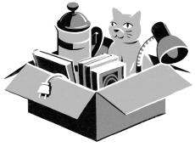
Sometimes, you use something that you don’t love or you need something even though you use it only once every five years. Or perhaps you love something that you never use. That’s okay—just because something isn’t being used doesn’t mean it’s useless.
But if you don’t need it, love it, or use it, you should probably get rid of it.
For any possession that passes this test, ask one additional question:
Where does it belong?
Every item should have a specific home.
NEVER LABEL ANYTHING “MISCELLANEOUS.”
And don’t use a term that’s a synonym for “miscellaneous.” I once created a file called    and then never looked in it again.
IDENTIFY YOUR BENEFICIARIES.
It’s much easier to let go of unneeded items when we can envision others getting good use from them, so identify people and organizations who will appreciate your contributions. I found it much easier to clear clutter once I identified:
an organization that accepts toys
an organization that accepts books
an organization that accepts clothes
a soup kitchen that accepts any unopened packages of food
a drugstore that safely disposes of unused prescription medications
a young family who needs children’s furniture
a child who loves dolls and stuffed animals
We had a big pile of board games and puzzles that we no longer used. It occurred to me to ask if my daughter’s summer camp would like them. The camp directors were pleased to get these activities for rainy days, and I was gratified to know that these items would be getting such hard use.
DONATE QUICKLY.
When we can’t make good use of our possessions, it’s time to get those things into the hands of people who will benefit from them. However, giveaways can quickly accumulate and become a source of clutter themselves. Create a system for moving things out of your house before too much time passes; if you don’t, those boxes and bags may take root in their temporary holding spots and stay there for months.
ASK YOURSELF,“DO I NEED MORE THAN ONE?”
As you’re clearing clutter, if you discover that you have more than one of an item, ask yourself, “Do I need more than one?”
While it can be helpful to have more than one phone charger and more than one pair of scissors, you probably don’t need two flour sifters or three pen cups on your desk.
Weirdly, it’s often easier to keep track of one than of multiples. When I have only one pair of sunglasses, I can always find them. When I have more than one pair, I get careless.
MEMENTOS SHOULD BE CAREFULLY CURATED AND, IF POSSIBLE, SMALL IN SIZE.
I’m a big believer in keeping things for sentimental reasons; remembering happy times in the past gives us a big happiness boost in the present. It’s important, though, to think carefully about the things we choose to keep.
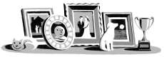
Those sweaters you wore in high school—could you keep one sweater instead of five? Or could you take a photo of them? Your grandfather’s desk—could you keep his pipe instead? The finger paintings your son brought home from preschool—could you frame your favorite masterpiece to hang on the wall and toss the rest?
The same is true at work. It’s easy for a desk to get crowded with trinkets, mementos, and photos that take up a lot of space without providing much value.
Curation matters. Usually (perhaps paradoxically) having fewer mementos allows us to hold on to more memories than having many mementos does, because these keepsakes have been carefully chosen and we’re less overwhelmed by the sheer volume.
Choose a few items that are truly exceptional, and clear out everything else. Find ways to hold on to memories without accumulating mounds of stuff.
Oh! Old rubbish! Old letters, old clothes, old objects that one does not want to throw away. How well nature has understood that, every year, she must change her leaves, her flowers, her fruit and her vegetables, and make manure out of the mementoes of her year!
JULES RENARD
BEWARE OF THE “EASY TO BUY, HARD TO USE” TRAP.
Some items are very easy and satisfying to buy—but then are hard to use.
Gadgets, cookbooks, tech solutions, exercise equipment.…They hold great promise, but only if we put them to proper use. And often that takes effort.
Do I really want to figure out how to set up that sleek new device? Am I really going to have the kind of party where I’d use those linen napkins? Am I really committed to using a treadmill? How often do I write a letter on nice stationery?
When deciding what to buy, remember that some things are easy to buy—but then we have to use them. If they’re not used, they don’t enhance our lives; they just contribute to guilt and clutter.
ALLOW TECHNOLOGY TO CLEAR CLUTTER.
Often we hang on to possessions that have been replaced by technology.
Do you consult the print manuals for your devices or appliances— or do you just look up the information online?
Do you maintain a library of books, DVDs, or CDs even though you don’t use them anymore?
Do you have a fax machine, even though you never send or receive faxes?
Maybe you still need an alarm clock, calculator, scanner, dictionary, thesaurus, etiquette guide, maps, or copier—but perhaps you use a tech solution instead, so you don’t need to keep those things.
If you have the current version of an item, don’t keep the outdated version. If you use a new Keurig to make your coffee every day, you don’t need your French press.
Unless you actually use these items, there’s no need to hang on to them any longer. (Though it does seem like a sacrilege not to own a physical copy of a dictionary.)
DON’ T AIM FOR “MINIMALISM.”
Outer order isn’t a matter of having less or having more; it’s a matter of wanting what we have.
For some people, owning a minimal amount of possessions makes them feel freer and happier. That’s absolutely true. But it’s not true for everyone.
Declaring that we’d all be happier with less (or with more) is like saying that every movie should be 120 minutes long. Every movie has a right length, and people differ in the number of possessions, and the types of possessions, with which they can meaningfully engage. One person is happy with a bare shelf that holds a single vase; another is happy with a shelf lined with books, photographs, and mementos. We must decide what’s right for us.
Rather than striving for a particular level of possessions—minimal or otherwise—it’s helpful to think about getting rid of what’s
superfluous. Even people who prefer to own many possessions enjoy their surroundings more when they’ve purged everything that’s not needed, used, or loved.
CONSIDER THIS CHECKLIST FOR A CLOTHES CLOSET.
Take stock of the items in your closet. As you pull out each garment, ask:
Does it currently fit?
Do you actually wear it?
Do you love it, or if not, is it truly useful?
Even if you love it, is it in such bad shape that you ought to get rid of it? I struggle with this.
How many interchangeable items do you own? If you have five pairs of khaki pants, you’re not likely to wear your two least favorite pairs.
Is it uncomfortable?
Have you worn it five times or fewer? It’s the rare item that’s worth keeping, even if it’s almost never been worn.
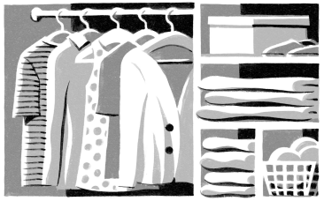
Do you worry that it’s out of fashion? If you think it might be, it probably is.
Can it only be worn in a limited way? Like a shirt that’s stained so it can only be worn under a sweater, or shoes that almost never work.
If you’re keeping an item only because it was a gift, does the giver know that you have it? If you don’t need to make a show of using it, you don’t need to keep it.
Does it work with other clothes that you have, or would you need to buy new items to make use of it?
Do you keep this item merely to fill a category? If you never wear something, you don’t need it. You don’t need any turtlenecks if you hate to wear turtlenecks.
Does it fill a need that no longer exists? This can be hard to admit, so press yourself.
Does it need to be altered before you can wear it? If so, get it altered or get rid of it.
Do you describe an item of clothing by saying, “I would wear that” or “I have worn that”? These phrases suggest that you don’t actually wear it.
Does your active closet hold clothes that you’re keeping for sentimental reasons or for wearing to a costume party? If so, store those items elsewhere. And be choosy; only save things that really deserve it.
Is a beloved item still flattering but not in top condition? You might “demote” it to more casual use. A sweater can go from a go out-to-dinner sweater to a hang-around-the-house sweater.
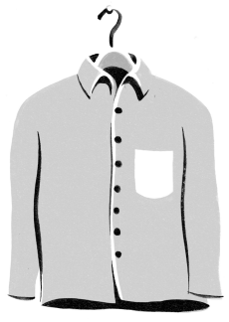
Life is barren enough surely with all her trappings; let us therefore be cautious how we strip her.
SAMUEL JOHNSON
USE A PHOTOGRAPH TO EVALUATE CLUTTER.
At home or at work, if you’re having trouble getting started, try taking photos of an area and evaluating what you see.
Somehow, a photograph helps us to see a space with fresh eyes. It changes our perspective and gives us a measure of detachment that can help us decide what items should stay and what need to go.
If someone argues against the need to clear clutter, try showing that person a photo of the space. The area may feel very comfortable —but the objective eye of the camera may help a person recognize that it needs to be cleared out.
Then, once you’ve cleared the space, take photos of it so that you can compare before and after images. It’s a big morale booster to see visual proof of what you’ve accomplished.
BEWARE OF THE “SOMEDAY, SOMEONE” RATIONALE.
Sometimes we keep an item because we imagine that “someday, someone will want this.”
Ask yourself: How likely is it that someday, someone will want this item?
At home, if something has a very specific use, is in poor condition, is dated, is of sentimental value, is bulky, requires a very particular decorative environment, or needs a lot of upkeep, it’s unlikely that it will be used. Someday, someone is likely to throw out that giant
aquarium, four-poster bed, damaged bicycle, stuffed animal, or bread maker from ten years ago.
At work, if an item is obsolete (a catalog from two seasons ago, a desk calendar from last year, outdated business cards), is broken, or belongs to a person who no longer works there, it’s unlikely that someday, someone will want it.
PROTECT YOUR PRIME REAL ESTATE.
When bringing order to our surroundings, it’s important to consider the value of the real estate.
For instance, a desk is extremely valuable real estate; be very selective about what’s on the surface of a work desk, as well as in any shelves, drawers, or cabinets that are within easy reach. Unless you’re consulting a book every day, don’t leave it on your desk. If you have three boxes of your favorite brand of pen, don’t store them in your top drawer.
It’s absolutely true that some people find that unexpected juxtapositions spark their creativity, and some people know exactly where to find anything in the pile on their desk. But even for them, work is easier when prime real estate is reserved for the most useful materials.
MOVE CLUTTER OUT OF CONTEXT.
When we see objects settled into a particular place over time, it becomes hard to imagine where else they might go.
So put your clutter into a new context. Pick up items, gather them in a box, and carry the box to a well-ordered room. Once you detach things from their settled places, it’s much easier to decide what to do with them.
MOST DECISIONS DON’ T REQUIRE EXTENSIVE RESEARCH.
In many situations, we don’t need to make a perfect choice but just a good-enough choice.
THREE STRIKES AND YOU’RE OUT.
My father once told me, “People are very reluctant to make a change, so when I started thinking that it might be time to switch jobs, I knew I probably should’ve switched jobs six months ago.”
Along the same lines, people are reluctant to relinquish their possessions, so if I think that it might be time to discard an item, I probably should’ve done so already—especially if that thought occurs to me more than once.
Now, if three times the thought has occurred to me, “I wonder if I should get rid of that,” I get rid of it.
Should I give away that broken tissue box in the shape of old books or keep it?
Should I shred those old credit card statements or retain them?
Should I donate those glass vases or hang on to them? Three strikes and you’re out.
ASK YOURSELF,“WHEN WAS THE LAST TIME I USED THIS POSSESSION?”
Some things are worth keeping even if they’re used only rarely: a good set of binoculars, a sled, formal wear, a box of matches, a cookie baking sheet, a can opener, and power adapters for travel.
But many things are used regularly—or not at all. Either you often use that white-noise generator, bowl for loose change, or electric toothbrush, or you never use it.
If you’re not using it, get it into the hands of someone who will use it.
BEWARE OF THE “ENDOWMENT EFFECT.”
Before you accept something for free or take advantage of a great deal, decide: Do I really need this thing? Do I love it?
Keep in mind that because of the “endowment effect,” we value things more once we own them. Once that thing enters your home, it will be tough to get it out again. A mug, a hand-me-down toy, the lamp from your mother-in-law—if you don’t need it, don’t take it. If you never possess an item, you don’t have to store it, dust it, find it, or figure out how to give it away.
When clearing clutter, one way to fight the endowment effect is to ask, “If I didn’t already own this possession, would I buy it?”
If not, why keep it?
ABANDON A PROJECT.
One source of clutter in our homes, and a significant drain on our energy, is the uncomfortable presence of unfinished projects. Whenever we see evidence of an unfinished project, we get a jolt of annoyance or guilt: “I should finish that,” “I need to deal with that,” “When am I going to find the time to get that done?”
These projects take many forms: knitting experiments, gardening plans, half-built Lego castles, binders full of untried recipes, woodworking projects, giant puzzles.
Unfinished projects are irritating in themselves, and they also contribute to clutter, because we often leave them out in the open, as a reminder to finish them.
Push yourself to finish an unfinished project or call an end to it. The easiest way to complete a project is to abandon it. Get that stuff off your shelf and off your conscience.
CONSIDER THE X FACTOR.
If you can’t decide whether to keep an item of clothing, ask yourself, “If I ran into my ex on the street, would I be happy if I were wearing this?” Often, the answer will give you a good clue.
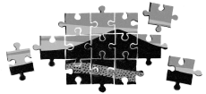
BEWARE OF THE “DURATION EFFECT.”
In my own life, I’ve noticed a phenomenon that’s related to the endowment effect—what I think of as the “duration effect.” The longer I own a possession, the more precious it becomes, even if it has never been particularly valued.
We have an ugly, badly designed pair of scissors, but my husband got them as a high school graduation gift—how can we get rid of the scissors now?
This phenomenon is strongest with any possession related to my children. My daughters never played with that china tea set, but now that we’ve had it for fifteen years, how can we give it away?
Because of the duration effect, I try to hurry unwanted things out the door. The longer I keep them, the harder it is to let them go.
BEWARE OF CONFERENCE SWAG, OFFICE FREEBIES, AND PROMOTIONAL GIVEAWAYS.
Yes, I went to that conference, and I received a branded mug, a T shirt, a metal water-bottle, a journal and pen, and an eraser in the
shape of a cow. But if I don’t have a clear plan to use these things, they’re clutter.
The best way to deal with clutter is never to accept these freebies in the first place. Something free can end up costing a lot of time, energy, and space.
FORECAST THE FUTURE.
Imagine that it’s far in the future and your relatives have arrived to clean out your house. What items will they want and what items will they give away, toss, or recycle? You can make their job in the future easier by dealing with your possessions now, instead of foisting that job on them.
ASK YOURSELF,“IS THIS POSSESSION MOVING AROUND?”
Many things, if well used, move around. Clothes come out of their drawers, go to the laundry, return to their place. Books circulate around the house. Dishes come out of the cabinets, get dirty, get clean. For these kinds of possessions, staying in one place for a long time is a clue that they may be clutter.
And are there whole rooms, whole closets, entire filing cabinets, or sets of shelves where nothing comes or goes? These areas begin to feel stale and stagnant, and if nothing they hold ever moves around, they should probably be cleared out.
DON’ T GET ORGANIZED.
When you’re facing a desk covered in papers, or a closet bursting with clothes, or countertops littered with piles of random objects, don’t say to yourself, “I need to get organized.” No!
Your first instinct should be to get rid of stuff. If you don’t own it, you don’t have to organize it.
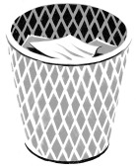
BEWARE OF “STORING” THINGS.
For some things—holiday decorations, seasonal clothes, vacation gear —storage makes sense. You put these things away, and when you need them, you get them out again.
But in many cases, storing a possession is just a way to delay deciding what to do with it. It’s tempting just to “collect and neglect”—that is, dump something in the attic or the basement rather than figure out whether and how to toss, recycle, or give it away. The U.S. Department of Energy estimates that 25 percent of people who
have two-car garages don’t park their cars inside because that space is used for storage.
In the long run, you’ll be happier if you don’t put much into “storage.” Before you squirrel something away, ask yourself, “Why am I keeping this?” Realistically, are you going to reread your old college textbooks?
TOSS UNNECESSARY PAPERS.
Paperwork is one of the toughest forms of clutter to vanquish. Getting rid of old papers is less satisfying than cleaning out a closet or a desk drawer, and it’s often much more anxiety-provoking.
To decide what to keep and what to toss, ask:
Do you actually need this piece of paper or receipt? What specific use does it serve?
Have you ever used it?
How easy would it be to replace it if you needed it? Except for items like old letters and journals, most things can be replaced.
Will it quickly become dated—like travel or shopping information?
Does the internet mean that it’s no longer necessary? For instance, the instruction manuals for most appliances are now online.
What’s the consequence of not having it if you do need it?
Was it once necessary but is now related to a part of your life that’s over?
Could you scan it, so that you have a copy if you need it? At work, does someone else have a copy of it?
Have you verified your assumptions? For instance, when you took your current position, your coworker told you, “I always keep these receipts,” so you assumed that you need to keep them, too. But maybe you don’t.
ONE OF THE BIGGEST WASTES OF TIME IS DOING SOMETHING WELL THAT DIDN’ T NEED TO BE DONE AT ALL.
I got an email from a teacher who complained about how much time she’d spent shredding old lesson plans and student essays. Why do those papers need to be shredded at all?
My sister had accumulated a huge mound of statements and receipts. She wanted to buy a file box to store everything away neatly, but she realized that she’d never needed the papers in the past and that it wouldn’t be hard to get copies if she ever did need them. So she tossed all of it.
She didn’t need to organize those papers at all.
MAKE A MOCK MOVE.
Moving is a great time to clear clutter. Often, when we must go to the trouble to pack up something, we realize that we don’t want it anymore.
Take advantage of this phenomenon by doing a mock move. Walk through your rooms, look at what you have, and ask yourself, “If I were moving, would I bother to wrap this in bubble wrap and stick it in a box? Or would I chuck it or give it away?” You may decide not to pack that battered Monopoly game, or the giant ceramic serpent that your daughter made in second grade, or the rice cooker that you’ve used only once.
So don’t wait for a real move. Make your home nicer by tossing, recycling, or donating these items now.
CLEAR CLUTTER BEFORE YOU MOVE, NOT AFTER YOU MOVE.
Moving from one house to another is a stressful, busy time, and it can be tempting to think, I’ll just pack everything and sort through it at the other end.
Try to do your sorting before you move. First, you’ll save the expense of moving something that you’ll eventually just toss or give away. Also, you want to outfit your pristine new home only with the
things that you truly need, use, or want. Don’t fill it—even temporarily —with useless or unwanted items.
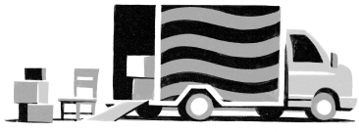
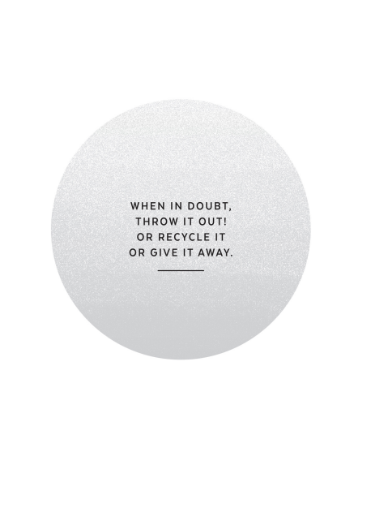
ESCAPE FROM CLUTTER LIMBO.
Sometimes, clutter is caused by uncertainty. That toy might be broken or maybe it just needs a new battery. The label-maker might be defective or maybe I didn’t push the correct button. This CD might be permanently scratched or maybe it would work if I wiped it off. Did I stop reading this novel, fifty pages in, because I didn’t like it or because I just misplaced it?
Move objects out of clutter limbo by taking the steps needed to decide their fate.
CONFRONT DEEP CLUTTER.
There’s clutter and then there’s deep clutter.
Deep clutter is easy to ignore. In deep clutter, items are well organized and put away neatly, and to the inattentive glance, everything looks great—but, in fact, these things are clutter because they aren’t used, needed, or loved.
For a long time, I maintained a big notebook with plastic sleeves that held business cards. I’d taken great satisfaction in how perfectly the business cards fit into their slots and how nicely the notebook fit on my shelf.
Then one day I realized that I hadn’t consulted a single business card in the past two years. The notebook and the cards were pure clutter. I cleared out the notebook and gave it away.
After we’ve eliminated the visible and annoying layer of clutter that lies on the surface of life, we can turn our attention to the deep clutter that weighs us down unnoticed.
CLEAR ANY OFF-SITE STORAGE UNITS.
Once you’ve stashed items in an off-site unit, it’s easy to forget about them. But you’re paying to store them, month after month after month.
Do you even know what’s inside your storage unit?
Visit your unit and make tough choices. If you never need or want these things, why are you keeping them?
FIGHT WASTE BY NOT ACQUIRING.
Many people have trouble clearing clutter because they hate the idea that they’re adding more junk to the landfill and putting more trash into the world. But once we own something, that object exists, whether it’s in the basement or at the dump.
If this is an issue for you—and even if it’s not—fight waste by not acquiring that item in the first place.
DON’ T FOIST YOUR CLUTTER ON OTHER PEOPLE.
Getting rid of things can be tough. One unhelpful strategy? To push our stuff onto other people.
Sometimes we press people to accept our things to relieve our own bad feelings: We feel guilty because we spent money on an item that we never used or because we’d like to replace a perfectly serviceable item with something new. To make ourselves feel better about this wastefulness, we push our possessions onto other people—who may or may not actually want them. We use generosity to disguise our true motives.
I’ve told myself, “I never wore this shirt, but I’ll give it to my daughter, and she can wear it” or “I never found a way to use this platter, so I’ll give it to my sister.” If these recipients really want to have these things, that’s wonderful, but I shouldn’t press them to be the receivers of my discards to avoid the prick of conscience.
They always say time changes things, but you actually have to change them yourself.
ANDY WARHOL
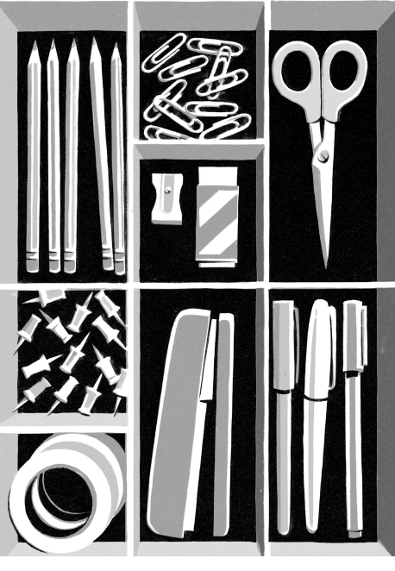
2
Create Order
To live in perpetual want of little things is a state, not indeed of torture, but of constant vexation.
SAMUEL JOHNSON
Once we’ve made the key choices about the fate of our possessions, we can begin to establish order.
Imposing order is difficult, but it’s also very satisfying to organize, to repair, to put things into their proper places, and to bring life to overlooked areas.
For most people, it’s deeply calming to see outer order emerge. Perhaps it’s the tangible sense of control, or the relief from visual noise, or the release from guilt and frustration. Creating order—even with things as mundane as socks or supplies—gives a disproportionate boost of energy and cheer. There’s so much we can’t control, but we can control our stuff.
Create order.
FIX YOUR “BROKEN WINDOWS.”
The “broken windows” theory of policing holds that when a community tolerates minor examples of disorder and petty crime, such as broken windows, graffiti, turnstile jumping, or drinking in public, serious crimes are more likely to ensue.
As a law-enforcement theory, it’s controversial, but whether or not it’s true on a citywide level, I think it’s true on a personal level. When our environment is disorderly, it’s easier for our behavior to become disorderly.
Some common personal broken windows include:
unsorted mail and unanswered bills
messy stacks of newspapers
shoes in odd places
no toilet paper
cluttered counters
dirty dishes scattered in every room
piles of laundry or trash
an unmade bed
It’s true that a pile of unsorted mail isn’t a big deal. Nevertheless, small instances of order make us feel more in control—and happier.
BEWARE OF “CLUTTER MAGNETS.”
In just about everyone’s house or office, certain areas become “clutter magnets.” When I was growing up, it was our dining room table. Nowadays, it’s the top of the chest of drawers in the hallway. Also a
certain chair in the bedroom. And the counter in my home office. Plus the kitchen table, of course. And I have a tendency to use the bedroom “floordrobe.”
Now, every night, I make a real effort to clear those areas. Why? Clutter attracts clutter, so once clutter begins to accumulate, an area tends to get worse and worse.
Get in the habit of clearing clutter magnets regularly. That way, the mounds can never grow too high.
REMEMBER: IF YOU CAN’ T RETRIEVE IT, YOU WON’ T USE IT.
Try to keep things stored within easy reach.
In general, it’s more useful to think about accessibility than to think about storage. If you want to store something but don’t care if it’s accessible—well, that’s a clue that you may not need to keep that item at all.
STOP SEARCHING.
Most of us have one item that somehow we can never find. We spend a lot of time and energy searching for our keys, sunglasses, phone charger, work badge, current book, and so on.
Identify your problem object and then find a way to solve the search problem.
Can’t find your keys? Put a hook in your front hall and always put your keys on that hook. Can’t find your phone charger once you get to work? Splurge to buy a few charging cords and place them in convenient spots—and never unplug them. Can’t find a pen? Buy a bag of pens and put a few in every drawer.
With a little thoughtful effort, we can save ourselves time and spare ourselves frustration.
DON’ T WAIT TO START CREATING ORDER.
At any age, decluttering a house can feel like an overwhelming prospect, and as we get older, it becomes even tougher to do a big sweep. It takes a lot of energy, time, physical strength, and taxing decision-making—plus, it’s emotionally draining.
So if your attic, basement, garage, guest room, or office needs to be tackled, don’t put off the task too long.
In fact, David Ekerdt, professor of sociology and gerontology, observed that after age fifty, the chances that a person will divest himself or herself of possessions diminishes with each decade.
This can be a real problem, for you and for others. Some people can’t move to a new place because they can’t face clearing out their current house, and so that burden falls to others.
Do it now. Waiting will make it harder, not easier.
SOAP AND WATER REMOVES MOST STAINS.
Usually, we don’t need highly specialized cleaning products to deal with common problems.
CHOOSE A “FLAVOR OF THE MONTH.”
To make clutter-clearing more fun, choose a theme for the month and focus on the objects in that theme. This approach is arbitrary, but that’s one reason that it’s effective: it helps us to see our environment in a new, playful way.
Possible themes? Books, clothes, toys, office supplies, kitchen equipment, or bathroom products.
BEWARE OF BUYING SOUVENIRS.
These items may seem wonderful when you’re visiting new places, but will you really want to have them on your shelves when you get home? If you do love to buy travel souvenirs, consider acquiring items that are small, easy to display or use, and yet are good at conjuring memories, such as Christmas tree ornaments, cooking spices, charms for a charm bracelet, postcards.
THINGS OFTEN GET MESSIER BEFORE THEY GET TIDIER.
Sometimes, it can be discouraging to clear clutter, because the process itself generates so much disorder.
It’s worth it.
IDENTIFY THE PROBLEM.
Make your workspace more convenient and orderly by taking the time to identify a specific problem.
Is your coat or sweater always in your way? Get a coatrack, use the common closet, or get a hook.
Are you constantly getting tangled in your headphones? Get a desk headphone hanger.
Do you constantly misplace paper with important information? Use a corkboard, take notes in a single notebook, create an in-box for “current vital info,” use a vertical file holder to keep papers organized yet within reach.
Many problems have simple solutions—once we take a moment to identify them.
IN ACTIVE AREAS, STRIVE TO KEEP SURFACES BARE.
Put away kitchen appliances you don’t use every day; don’t cram stuff onto every inch of your desk. Some people thrive in abundance and overflow, but even for them it’s helpful to have some clear areas for active work.
DECLARE A CLUTTER AMNESTY DAY.
Often, we feel guilty for spending too much money on possessions that we didn’t really need. And we feel guilty for buying possessions that we’ve never used at all. And we feel guilty about adding our forsaken possessions to the junk heaps of the world.
Because of that guilt, we hang on to possessions even when we don’t want, use, or love them.
Declare a Clutter Amnesty Day. All guilt is absolved. All mistakes are forgiven. Clear that clutter.
The fact is, done is done. Recycle all the unread magazines and articles. Give away unworn clothes, dusty dishes, and abandoned equipment. Declare an end to unfinished projects. Get rid of that single mitten. Then start afresh.
Set all things in their own peculiar place, And know that Order is the greatest Grace.
JOHN DRYDEN
CREATE A “TECH SACK.”
Gather any tech items you often use—such as a power cord, wall adapter, headphones, headphone adapter, external power supply—and create a “tech sack” that you can store in a drawer or throw into your briefcase, backpack, purse, or luggage.
BE A TOURIST IN YOUR OWN HOME.
Visit every place in your home or office. See what’s inside every cabinet, drawer, closet, and crawl space. Don’t feel pressure to deal with it, just look.
When I went on my tour of my apartment, I found troves of plastic cups, thumbtacks, and cotton balls.
Most of us have lots of overlooked areas, where stuff has been stored and forgotten for years. No matter how useful an item might prove to be, if we don’t know we possess it, we can’t use it.
BATTLE YOUR DUNGEONS.
Most of us have dungeonlike areas in our surroundings—places that seem dank, dirty, neglected, even haunted.
That’s unpleasant, so take steps now to eliminate this nastiness. Make sure that no area in your home smells bad, feels dirty, or seems
abandoned.
Deal with anything that’s sticky, moldy, or musty, whether it’s an old jar of honey, a cosmetics bottle streaked with foundation, an oily toolbox, a mildewed shower curtain, a bag of nuts that smells stale, or a laundry-room floor covered with a layer of soap.
If possible, figure out why an area might be damp or crumbling or unstable, and fix it.
In particular, pets can be a source of nastiness: stinky kitty litter, masses of dog hair, smelly aquarium water, old carpets, open bags of food.
These disagreeable and neglected areas weigh us down, so by transforming them, we make the experience of our homes more pleasant.
Brass shines with constant usage, a beautiful dress needs wearing; leave a house empty, it rots.
OVID
ASSIGN EACH DAY ITS OWN TASK.
I love the Little House books of Laura Ingalls Wilder. As a child reading Little House in the Big Woods, I was fascinated by the idea of assigning a particular household chore to each day of the week. According to Laura,
Wash on Monday,
Iron on Tuesday,
Mend on Wednesday,
Churn on Thursday,
Clean on Friday,
Bake on Saturday,
Rest on Sunday.
This approach can be adapted to the work week, for tasks that are best done periodically. You might…
Update spreadsheet on Monday,
Process expense receipts on Tuesday,
Work on monthly report on Wednesday,
Invoice on Thursday,
Make phone calls on Friday.
CREATE A “MYSTERY BOX.”
We all accumulate those unattached, important-looking pieces: orphaned cables, random remote-control devices, important-looking screws that appeared on the floor one day, obscure vacuum-cleaner attachments. Collect them all and put them in a box. You’ll never use these items, but you’ll know they’re there. For extra credit, put a date on the box, and if you haven’t opened it in a year, throw it away.
SOMETHING THAT CAN BE DONE AT ANY TIME IS OFTEN DONE AT NO TIME.
Do it now, or decide when you’ll do it.
IMAGINE THAT YOU’RE THROWING A PARTY.
Nothing inspires clutter-clearing more than the knowledge that a bunch of people will be visiting.
Even if you’re not planning a party now, imagine that you are. Set a date in your mind and ask yourself, “If I’m hosting twelve people for brunch next Sunday, what do I need to do to prepare?”
Really try to put yourself in the host mind-set. It’s astonishing how many overlooked aspects of your home will spring into your awareness: the fingerprints on the doorjamb, the crumbs in the fridge, the giant toy pile in the corner of the living room.
Along the same lines…
IMAGINE YOUR HOME THROUGH THE EYES OF A STRANGER.
Walk around your house as if you were a real estate agent preparing to put it on the market. With a dispassionate eye, evaluate its worth. What aspects might drag down its value and what changes would allow it to command a better price? That junk room could be transformed into an office or an exercise room. Those overloaded shelves could be cleared out. Those burned-out light bulbs could be replaced.
Or imagine that you’re someone who’s considering paying for a short-term rental of the space. What would you think of those photos on the Airbnb website?
Or imagine that you’re the executor of the estate, or a professional organizer, or a house cleaner called in to bid on a big job. By assuming another identity—a stranger who doesn’t have a personal love for our possessions and space—we foster the detachment that makes it easier to create order.
It is by studying little things that we attain the great art of having as little misery and as much happiness as possible.
SAMUEL JOHNSON
IDENTIFY AN EXACT PLACE FOR EVERYTHING.
Counterintuitively, it’s easier—and also more fun—to put things away in an exact place rather than a general place.
Life goes more smoothly when you know exactly where to find certain essential possessions. For instance, know where to find your:
passport
flashlight
vegetable peeler
Band-Aids
AA batteries
heating pad
pair of scissors
last year’s tax returns
screwdriver
birth certificate
teaspoon measure
packing tape
Added benefit: When things belong in an exact place, it’s easier for other people to find them, and it’s easier for other people to put things away. Everybody knows that the extension cord belongs on the left side of the closet’s third shelf.
GET ORGANIZED—
BUT NOT TOO ORGANIZED.
There’s great pleasure and value in having a place for everything, but this impulse can become inefficient. Don’t get overly specific. If you spend a lot of time alphabetizing your soup cans or setting up fifteen categories for your home library, consider simplifying your approach.
Also, some things simply won’t stay organized, so it’s not even worth trying; I’ve spent hours sorting crayons and Lego pieces, only to find them all jumbled up again the next day.
BEWARE THE SIREN CALL OF INVENTIVE STORAGE CONTAINERS.
Perhaps unsurprisingly, it’s often the people with the worst clutter problems who have the instinct to run to a store to buy complicated hangers, drawer compartments, and so on.
Don’t buy a container until it’s absolutely clear that it will help you organize objects that are truly necessary—rather than act as a crutch to move clutter around or to jam more clutter into place.
If you need to buy things to store things, perhaps you have too many things.
Don’t spend money on containers for possessions that will be packed away nicely, then utterly forgotten. The right container can be invaluable, but if you get rid of the things you don’t need, use, or love, you may not need those containers at all.
PRACTICE MISE-EN-PLACE.
Sophisticated cooks talk about mise-en-place, which is French for “everything in its place.” Mise-en-place describes the preparation that’s done before the actual cooking starts: gathering ingredients and implements, chopping, measuring, and all the rest.
Mise-en-place means that a cook has everything at the ready, with no need to make a trip to the store or begin a frantic search for a paring knife.
Whenever possible, practice mise-en-place. Creating order is easier when we take the time to set up properly. Is your mail situation out of control? Establish a place where you can find your stamps, envelopes, return-address labels, checkbook, and letter opener. As soon as you’re ready to act, the materials are ready for your use.
CLEAN AS YOU GO.
Clean as you cook, hang up your clothes right after you put on your pajamas, put files back in the filing cabinet as soon as you’ve retrieved what you need. If you clean up after yourself along the way, clutter stays far more manageable.
For most people, it’s easier to do little tasks as they arise rather than face a giant task at the end.
CREATE A “BOWL OF REQUIREMENT.”
In the Harry Potter books, Harry finds a Room of Requirement that magically holds anything a person requires. Inspired by this idea, I now create a “bowl of requirement” every time I travel to a new place.
I find a bowl or a tray and in it I place anything that might be required by me or a member of my family: keys, sunglasses, earbuds, loose change, wallet.
I’d noticed that when traveling, I often misplaced things because I put them down randomly, in an unfamiliar setting. By identifying a place where everything important should go, I’ve spared myself hours of irritated searching.
CREATE HOLDING BINS.
When people share a space—a couple, a family, roommates in a dorm, officemates—they often have different levels of tolerance for clutter. And this can cause a lot of arguments.
If you crave order more than the other people who share your space, consider creating holding bins for their stuff. Keep these bins somewhere inconspicuous yet convenient, and when you want to create more order, put their out-of-place items in their bins. It’s a lot quicker and easier than putting things away in their proper places— especially if you don’t know where those things belong.
This way, items are out of the common areas, yet easily found by their owners. If necessary, you can also have an extra bin for items without a clear owner.
KEEP PENS, A NOTEPAD, SCOTCH TAPE, AND A PAIR OF SCISSORS IN EVERY ROOM.
Life is much easier when you have the tools you need right within reach.
FIND A PLACE FOR ITEMS THAT ARE NEITHER DIRTY NOR CLEAN.
Many people struggle to manage clothes that are neither fresh from the washing machine nor ready to be laundered: the sweatpants you’ve worn a few times, the shirt you wore for an afternoon.
When people feel uncomfortable mixing not-dirty clothes with clean ones, they tend to accumulate clothes in odd places. If you feel this way, find a method for handling those in-between clothes. Put hooks for them in your bathroom or closet; set aside a special drawer.
WHAT WE ASSUME WILL BE TEMPORARY OFTEN BECOMES PERMANENT; WHAT WE ASSUME IS PERMANENT OFTEN PROVES TEMPORARY.
Begin the way you want to continue, because temporary often becomes permanent. If members of your family dump their stuff on the floor of the front hallway during the first few weeks you live in your new house, everyone will form a habit that will be hard to change —so work hard to establish desirable habits right from the first day.
On the other hand, what seems permanent often proves temporary. You may think that you’ll have a grubby high chair in your kitchen forever, but before you know it, that high chair will be gone.

